

Semester One Examination 2017

Question/Answer Booklet

MATHEMATICS
METHODS UNIT 1

Section Two:
Calculator-assumed

Student Name: _____________________________________

Teacher’s Name: _____________________________________

Time allowed for this section
Reading time before commencing work: ten minutes
Working time for paper: one hundred minutes

Material required/recommended for this section

To be provided by the supervisor
This Question/Answer booklet
Formula Sheet (retained from Section One)

To be provided by the candidate
Standard items: pens(blue/black preferred), pencils(including coloured), sharpener, correction tape/fluid, erasers, ruler, highlighters

Special Items: drawing instruments, templates, notes on two unfolded sheets of A4 paper, and up to three calculators approved for use in the WACE examinations.

Important note to candidates
No other items may be taken into the examination room. It is your responsibility to ensure that you do not have any unauthorised notes or other items of a non-personal nature in the examination room. If you have any unauthorised material with you, hand it to the supervisor before reading any further.

Structure of this paper

 | Number of questions available | Number of questions to be attempted | Suggested working time (minutes) | Marks available | %
Section One  Calculator—free | 8 | 8 | 50 | 51 | 35
Section Two  Calculator—assumed | 13 | 13 | 100 | 99 | 65
 |  |  |  | 150 | 100

Instructions to candidates

- The rules for the conduct of Western Australian external examinations are detailed in the Year 12 Information Handbook 2017. Sitting this examination implies that you agree to abide by these rules.

- Answer the questions according to the following instructions.

Section Two: Write answers in this Question/Answer Booklet. Answer all questions.

Show all your working clearly. Your working should be in sufficient detail to allow your
answers to be checked readily and for marks to be awarded for reasoning. Incorrect
answers given without supporting reasoning cannot be allocated any marks. For any
question or part question worth more than two marks, valid working or justification is required to receive full marks. If you repeat an answer to any question, ensure that you cancel the answer you do not wish to have marked.

It is recommended that you do not use pencil, except in diagrams.

- You must be careful to confine your responses to the specific questions asked and to follow any instructions that are specific to a particular question.

- Spare pages are included at the end of this booklet. They can be used for planning your responses and/or as additional space if required to continue an answer.
- Planning: If you use the spare pages for planning, indicate this clearly at the top of the page.
- Continuing an answer: If you need to use the space to continue an answer, indicate in the original answer space where the answer is continued, i.e. give the page number. Fill in the number of the question that you are continuing to answer at the top of the page.

- The Formula Sheet is not handed in with your Question/Answer Booklet.

Section Two: Calculator–assumed 99 marks

This section has thirteen (13) questions. Attempt all questions. Write your answers in the spaces provided.

Spare pages are included at the end of this booklet. They can be used for planning your responses and/or as additional space if required to continue an answer.

- Planning: If you use the spare pages for planning, indicate this clearly at the top of the page.
- Continuing an answer: If you need to use the space to continue an answer, indicate in the
original answer space where the answer is continued, i.e. give the page number. Fill in the
number of the question(s) that you are continuing to answer at the top of the page.

Working time: 100 minutes

Question 9 (5 marks)

(a) The volume (V) in litres (L) of a gas, at a fixed temperature and of a certain mass, varies inversely to the pressure (P) in Pascals (Pa).

(i) Find k, the constant of proportionality, given that when P = 11.5 Pa and V = 2.84 L.
(2 marks)

(ii) Describe the effect on V when P is halved. (1 mark)

(b) Jan is a real estate agent who earns a commission of 3.25% on the sale of a house. If $c is the commission and $s is the sale price of a house, show clearly c is directly proportional to s. (2 marks)

Question 10 (9 marks)

Given the following:

(a) Complete the tree diagram showing all the probabilities. (3 marks)

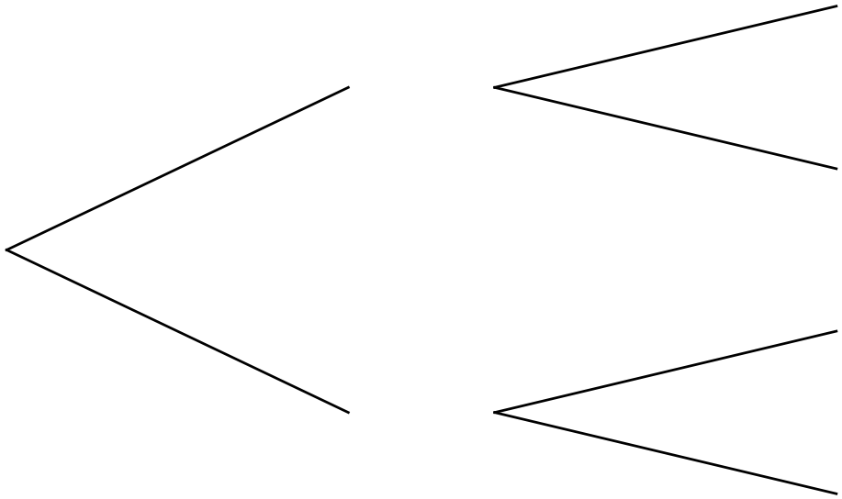

(b) Determine the following:

(i) P() (1 mark)

(ii) P() (1 mark)

(iii) P(R) (2 marks)

(iv) P() (2 marks)

Question 11 (5 marks)

The reciprocal function 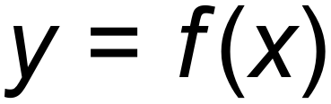 shown below has asymptotes at  and 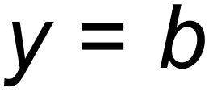.
The y-intercept is at (0, c).

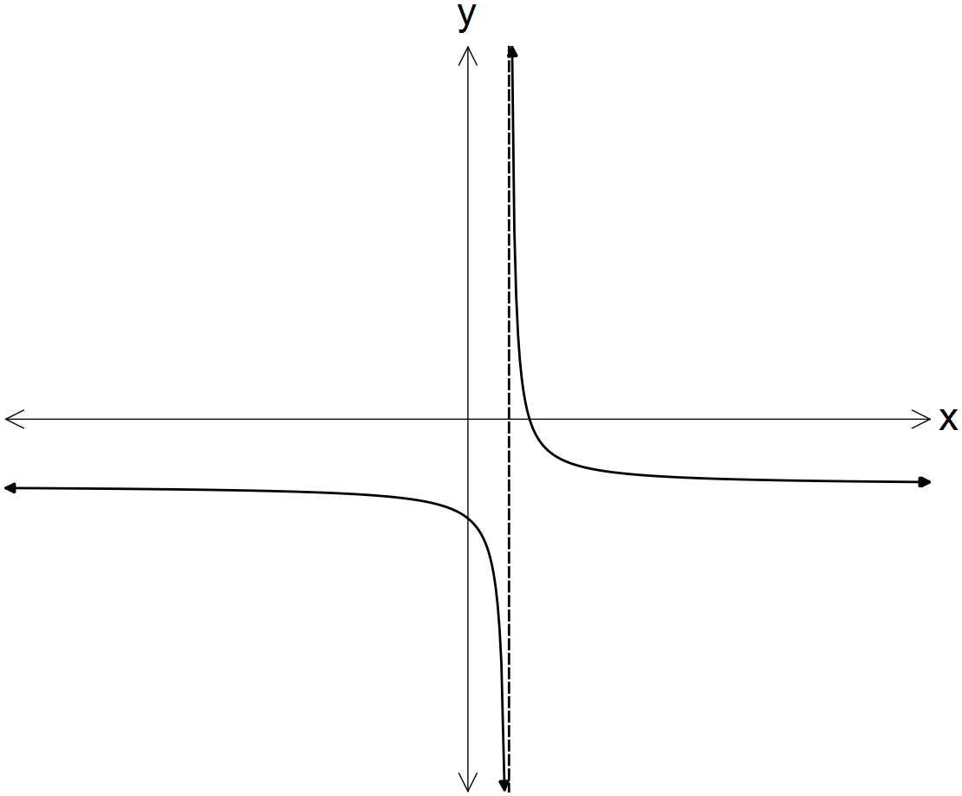

In terms of a, b and/or c:

(a) determine the equation of the horizontal asymptote for 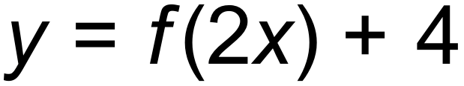. (1 mark)

(b) determine the coordinates of the y-intercept of 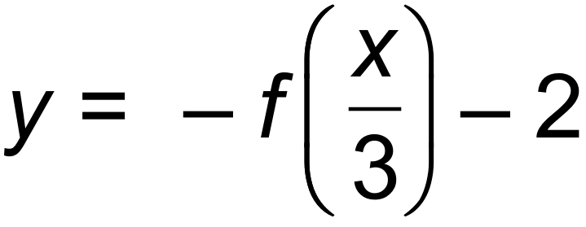. (2 marks)

(c) state the domain of the function 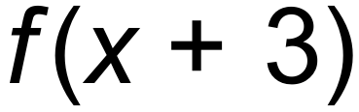. (2 marks)

Question 12 (8 marks)

(a) Given that 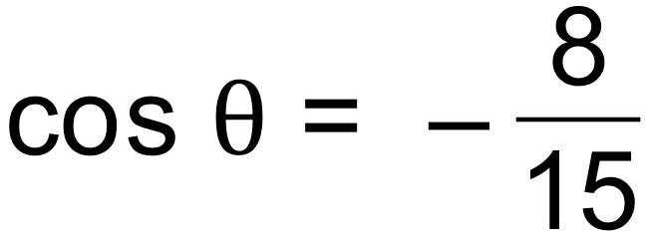 and  is positive, find the exact value of 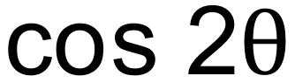. (4 marks)

(b) Bruno stands on a cliff, AB, 123 m above sea level. He observes two boats on the sea. The angle of depression for the boat further away at D is 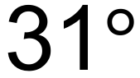 and for the boat closer to the cliff at C is 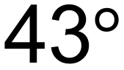. How far apart are the two boats to the nearest metre? (4 marks)

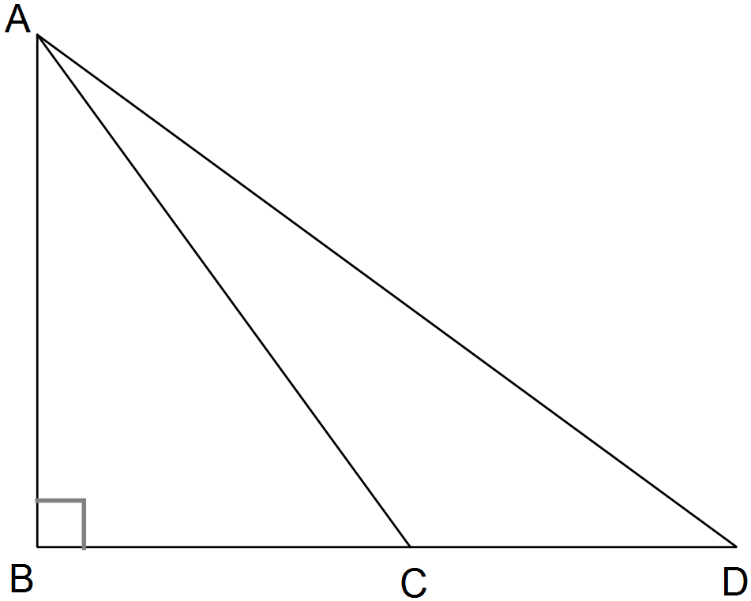

Question 13 (9 marks)

The probability of a Year 11 student in a certain school studying Media Studies or Literature is 0.3.
 of the students study Media Studies and  of the students study Literature.

(a) Complete the Venn diagram. (3 marks)
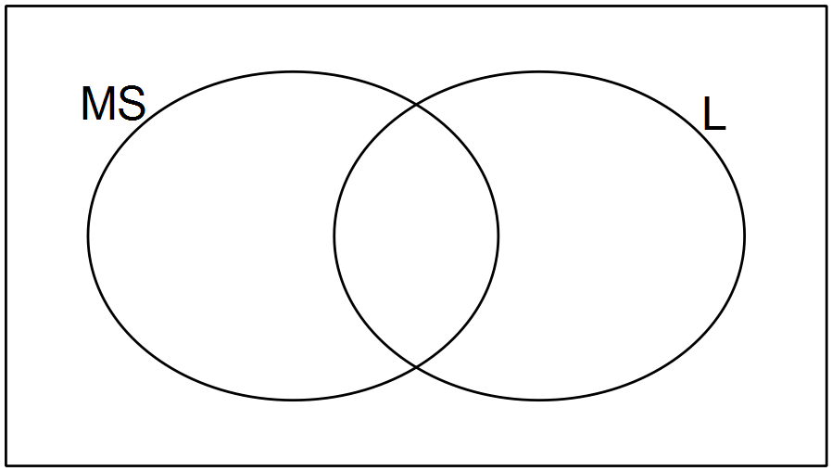

(b) What is the probability of a student studying both Media Studies and Literature? (1 mark)

(c) If there are 190 students in Year 11, how many students take neither subject? (1 mark)

(d) Given that a student studies Literature, what is the probability that she studies Media Studies? (2 marks)

(e) Are the two events independent? Justify your answer mathematically. (2 marks)

Question 14 (10 marks)

(a) Consider the following sets of ordered pairs:
f = { (1,2), (2, 3), (3,4) } h = { ( 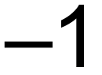, 4), (0, 3), (1,2) }

(i) Find f (2). (1 mark)

(ii) Find a such that h (a) = 3. (1 mark)

(iii) Find t such that f (t) = h (t). (1 mark)

(b) Compare the domain of 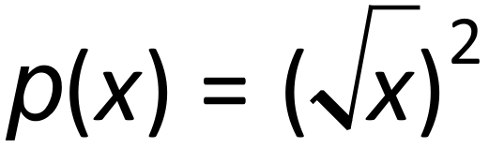 and 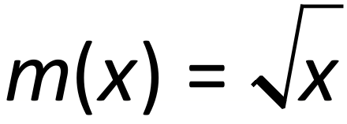. (2 marks)

(c) (i) The function, 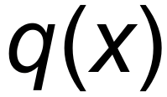 below, is a transformation of 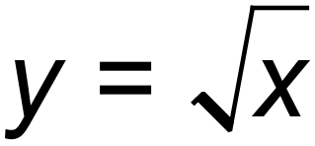.
State the equation of the function, 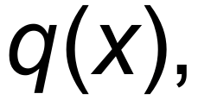 below. (2 marks)

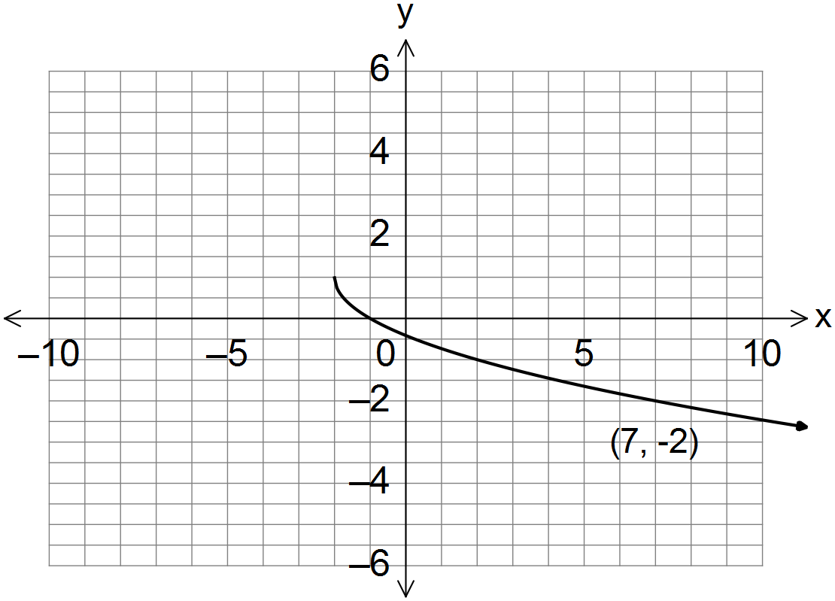

___________________________

(ii) On the same set of axes draw the transformed function 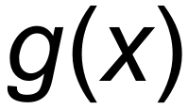 such that 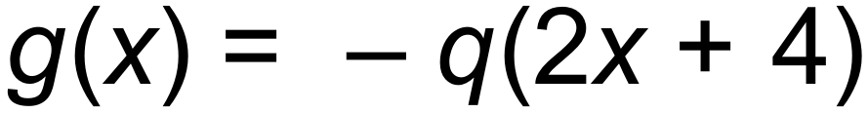. (3 marks)

Question 15 (6 marks)

The following functions are shown below:
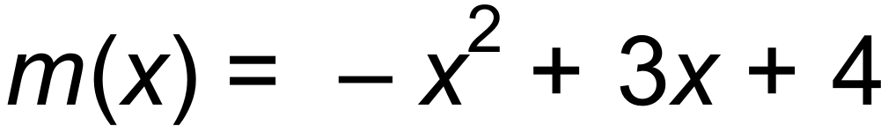 and 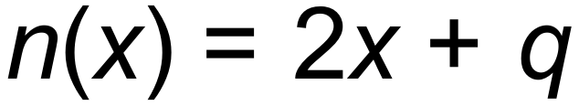, where q is a constant.
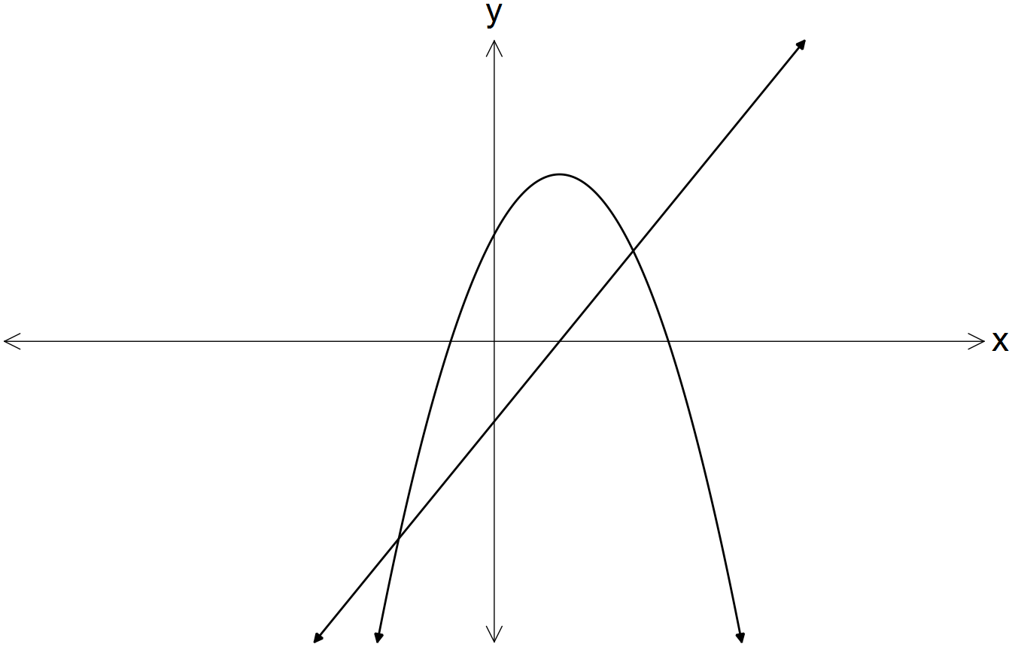

For what value(s) of q does the equation 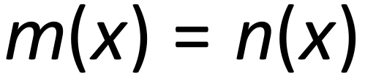 produce:

(a) one solution? (4 marks)

(b) no real solutions? (2 marks)

Question 16 (7 marks)

Two circles shown below, with centres B and C, each have a radius of 50cm, while a smaller circle, with centre A, has a radius of 30 cm.
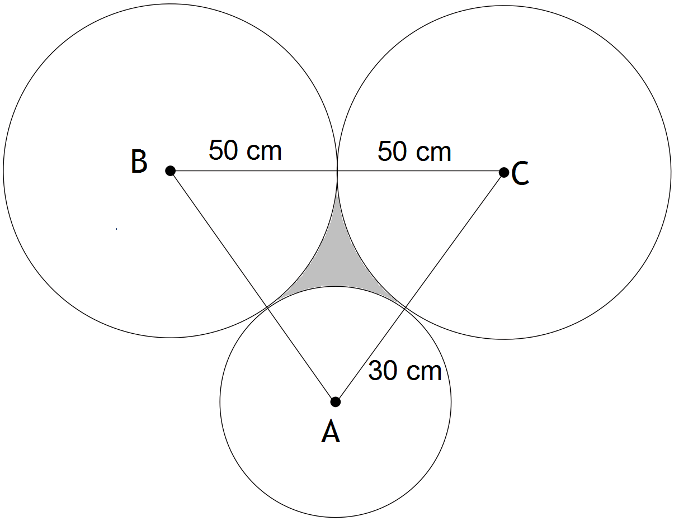
(a) Determine the area of triangle ABC. (3 marks)

(b) Find the area of the shaded section between the circles, to the nearest square centimetre.
Show your reasoning. (4 marks)

Question 17 (10 marks)

(a) The 5 Olympic rings are each painted a different colour. A painter is asked to paint the five rings of the Olympic Games on a sports oval. He cannot remember the colours, but he knows they are all different. He has eight colours of paint with him.

(i) In how many ways can he paint the rings on the sports oval? (2 marks)

(ii) What is the probability that he chooses the correct colours? (1 mark)

(b) The first four rows of Pascal’s triangle can be written as follows:

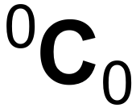
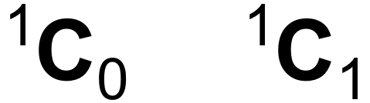
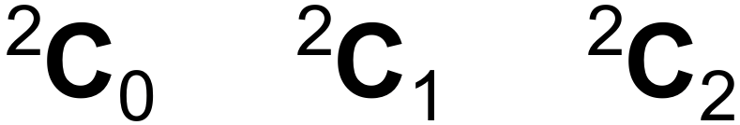
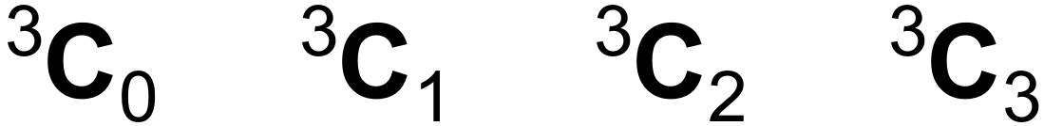

(i) Show how you would use the fifth row of Pascal’s triangle above to expand 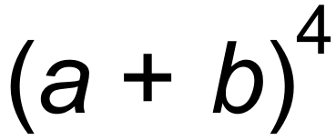.
(2 marks)

(ii) Determine the fourth term in the expansion 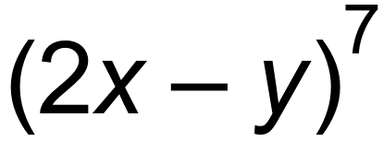. (2 marks)

(c) Six females and five males are interviewed for five positions in a company. If all applicants are acceptable for any position, in how many ways could the following combinations be selected?

(i) Three males and two females. (1 mark)

(ii) At least four females. (2 marks)

Question 18 (9 marks)

(a) Find the equation of a straight line which passes through the point (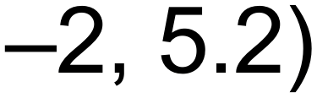 and makes an angle of 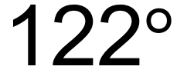 with the positive direction of the x-axis. (2 marks)

(b) Complete the square to find the co-ordinates of the turning point of the function
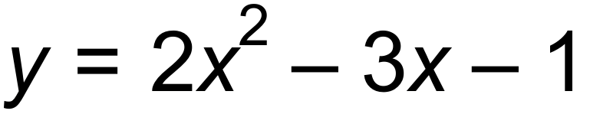. (3 marks)

(c) A cricketer struck a cricket ball such that its height above the ground, h (metres), after it had travelled d metres horizontally is modelled by the rule 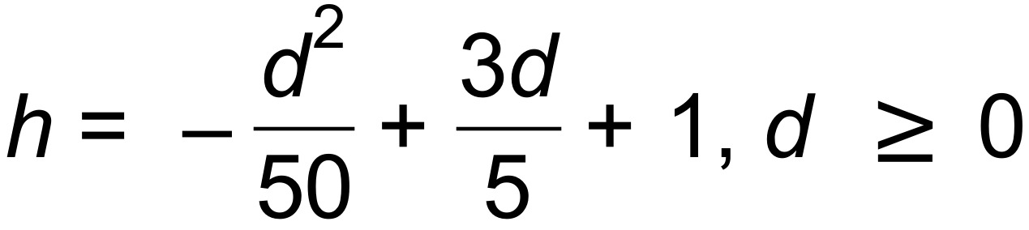.

(i) At what height was the ball when it was struck by the cricketer’s bat? (1 mark)

(ii) What was the maximum height reached by the cricket ball? (1 mark)

(iii) If a fielder caught the ball when it was 2 m above the ground, how far was
the fielder from the batsman? (2 mark)

Question 19 (6 marks)

(a) Write the equation of a sine function with the following features:
an amplitude of 2
a phase shift of 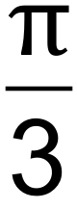 to the right
a period of 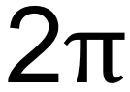
a vertical translation of 1 in the negative direction (2 marks)

(b) Draw the function from (a) on the axes below for the domain 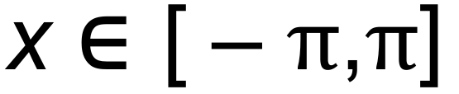: (3 marks)

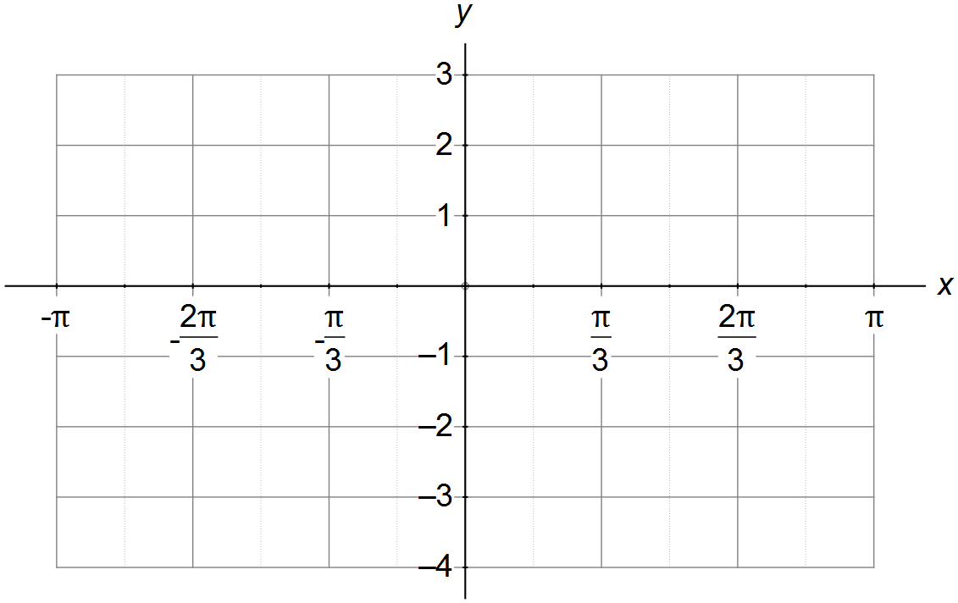

(c) Use the graph from (b), or otherwise, to find the solutions to 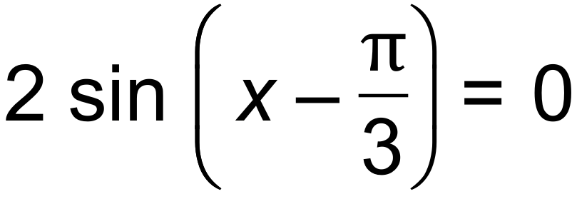 in the given domain. (1 mark)

Question 20 (10 marks)

G and H are events such that P(G) = 0.7, P() = 0.4 and 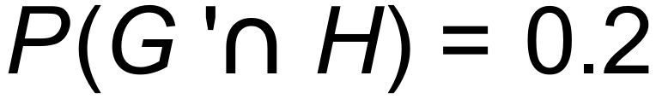.

(a) Complete the two-way table below. (3 marks)

 | H | 


 |  |  | 1

(b) Find:

(i)  (1 mark)

(ii) 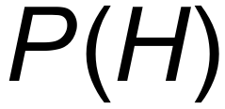 (1 mark)

(iii) 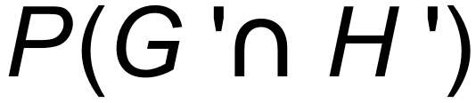 (1 mark)

(iv) 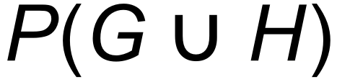 (1 mark)

(v) 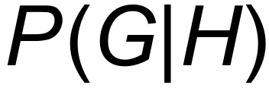 (2 marks)

(c) Show that G and H are not mutually exclusive. (1 mark)

Question 21 (5 marks)

(a) State the centre, C, and the radius, r, of the circle given by 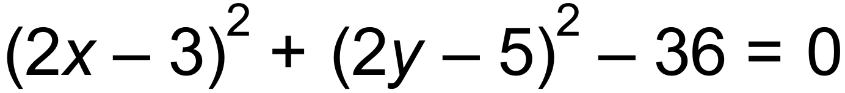.
(2 marks)

(b) Write a possible equation, in terms of a, b and/or c, which are positive constants, for each graph shown below.
(3 marks)
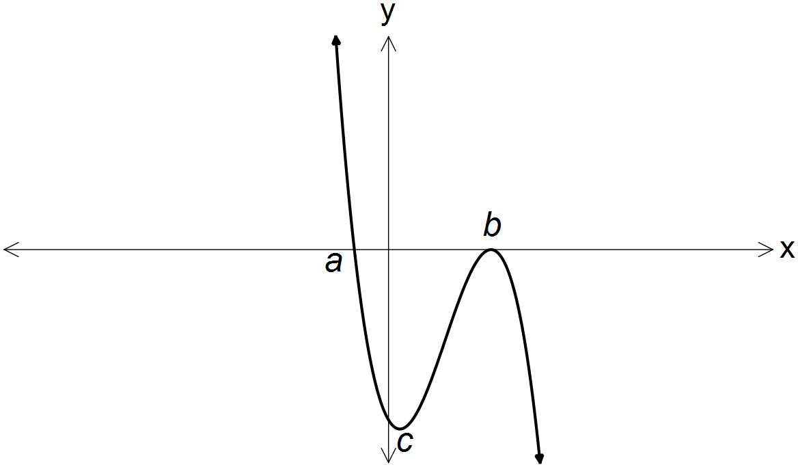 (i)

_________________________

(ii)
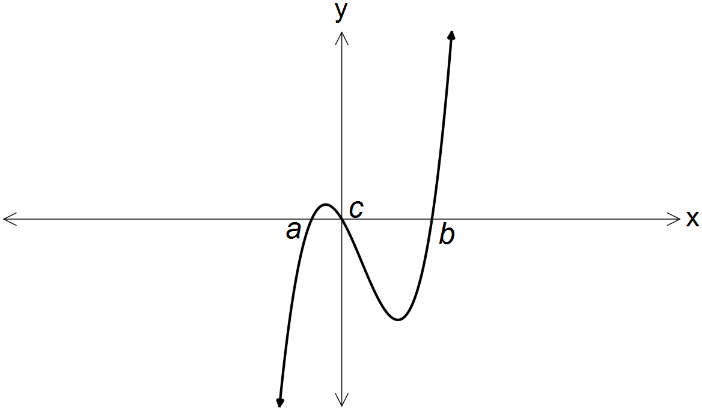

_________________________

(iii)
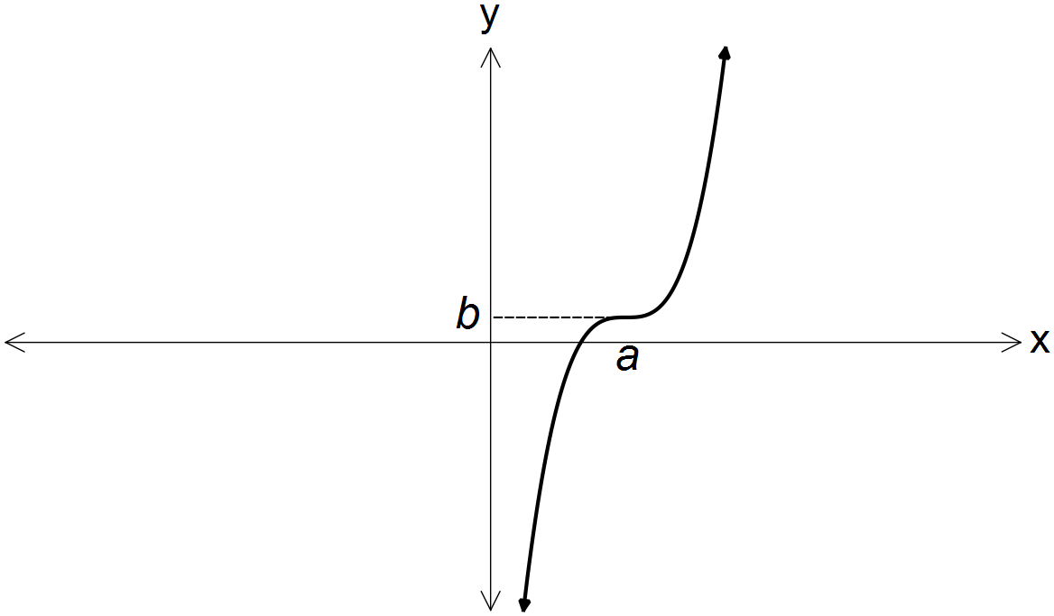

_________________________

END OF QUESTIONS

Additional working space

Question number(s): ……………………

Additional working space

Question number(s): ……………………

WATP acknowledges the permission of School Curriculum and Assessment Authority in
providing instructions to students.

